POWER BI, PROJECT ON

FIFA WORLD CUP ANALYTICS CASE STUDY (2002-2018)
BY
ANALYST RUTH MICHAEL MODEBE

1. Introduction
The FIFA World Cup, often simply called the World Cup, is an international association football competition contested by the senior men’s national teams of the members of the Fédération International de Football Association (FIFA), the sport’s global governing body. The championship has been awarded every four years since the inaugural tournament in 1930, except in 1942 and 1946 when it was not held because of the Second World War. The current champion is France, which won its second title at the 2018 tournament in Russia.
The 21 World Cup tournaments have been won by eight national teams. Brazil have won five times, and they are the only team to have played in every tournament. The other World Cup winners are Germany and Italy, with four titles each; Argentina, France, and inaugural winner Uruguay, with two titles each; and England and Spain, with one title each.
I was employed as a Data Analyst. I was asked to perform a detailed five-years analysis on FIFA World Cup.

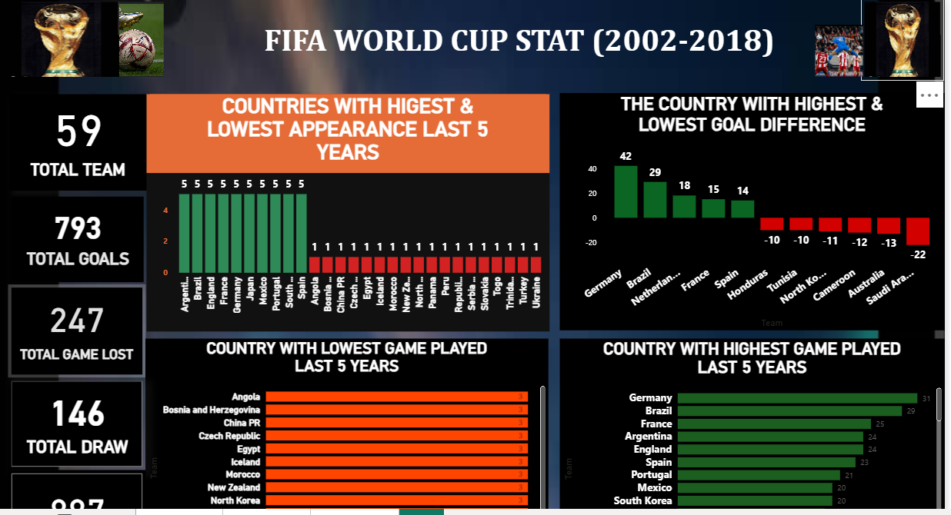

General Questions
1. How many countries have played in the World Cup (5 years)?
2. Get the total games played, win, loss, Goals for/against.
3. The country with the highest and lowest appearance in the last five years?
4. The country with the highest and lowest games play?
5. The country with the highest and lowest games won?
6. The country with the highest and lowest games lost?
7. The country with the highest and lowest goals for?
8. The country with the highest and lowest goals against?
9. The country with the highest and lowest goals different?
10. The country with the highest and lowest points?
These questions form the foundation for evaluating team strengths, performance consistency, and competitive trends over time.
3. Methodology
Data Preparation
Imported raw historical FIFA datasets into Power BI
Cleaned and transformed the data by:
Removing duplicates
Standardizing country names
Fixing missing values
Created essential DAX measures including:
Total Games Played
Wins, Draws, Losses
Goals For (GF)
Goals Against (GA)
Goal Difference (GD = GF – GA)
Total Points

Data Modelling

Created ranking and comparison tables using:
TOPN
RANKX
CALCULATE with filters.
Visualization
Used Power BI visual elements to enhance storytelling.
KPI Cards for performance summaries
Stacked & Clustered Column Charts
Tables for top and bottom performers
Line/Bar Combo charts for goal trends
Custom color themes to highlight insights.

4. Key Insights & Findings
A. Participation
A total of number of countries (59) participated between 2002 and 2018.
Only a few nations appeared consistently across all tournaments highlighting strong footballing structure and qualification strength.
B. Games Played
Total game played=640
Country with the Highest Games Played: (Country: Germany, Brazil, France etc.)
Indicates deep progression into knockout stages.
Lowest Games Played:( Country: Angola, China PR, Egypt)
Suggests early group-stage exits.

C. Games Won
Most Wins: Country Like Germany, Brazil, France, Argentina.
Shows tactical strength and elite performance.
Least Wins: Several teams recorded zero wins, indicating either tough group dynamics or weaker squads.

D. Goals For (GF)
Most Goals Scored: Country like Germany, Brazil, Spain, Argentina.
Highly efficient attacking performance
Lowest Goals Scored: Country like Angola, China pr, Egypt.
Reflects poor offensive execution.
E. Goals Against (GA)
Highest GA: Country like Brazil, south Korea, Australia
Defensive weaknesses or mismatched group pairings
Lowest GA: Country Bosnia, Czech Republic and Morocco
Excellent defensive discipline

F. Goal Difference (GD)
Best GD: Country like Angetina, Brazil, England, Germany etc.
Strong balance between attack and defense
Worst GD: Country like Angola, China pr Iceland etc.
High concession of goals indicating overall poor performance

G. Points
Most Points: Country like Germany, France, Brazil, Argentina and Spain
Typically, teams that consistently reach semi-finals or finals
Least Points: Teams with 0–1 point, usually exiting early with minimal impact.
Countries like: Iceland, Czech Republic, Bosnia and south Africa

5. General Observations
1. Teams with consistent appearances tend to maintain strong development programs.
2. Goal Difference (GD) is the most reliable indicator of tournament success.
3. Strong defensive teams advance further even if not high scoring.
4. Countries with recurring low performance need:
Better talent management
Stronger coaching systems
More competitive match exposure

6. Conclusion
This analysis provides a comprehensive overview of team performance across five World Cup tournaments.
It showcases my mastery in:
Data cleaning & modelling
DAX calculations
Power BI Visualization
Performance interpretation
Data storytelling

